Lab Assignment Day3

01_Aaditya Sudhir Joshi

1. Display the records from emp table having employee names starts with letter ‘M’

Answer:- Command => select * from employee where emp_name like ‘M%’;

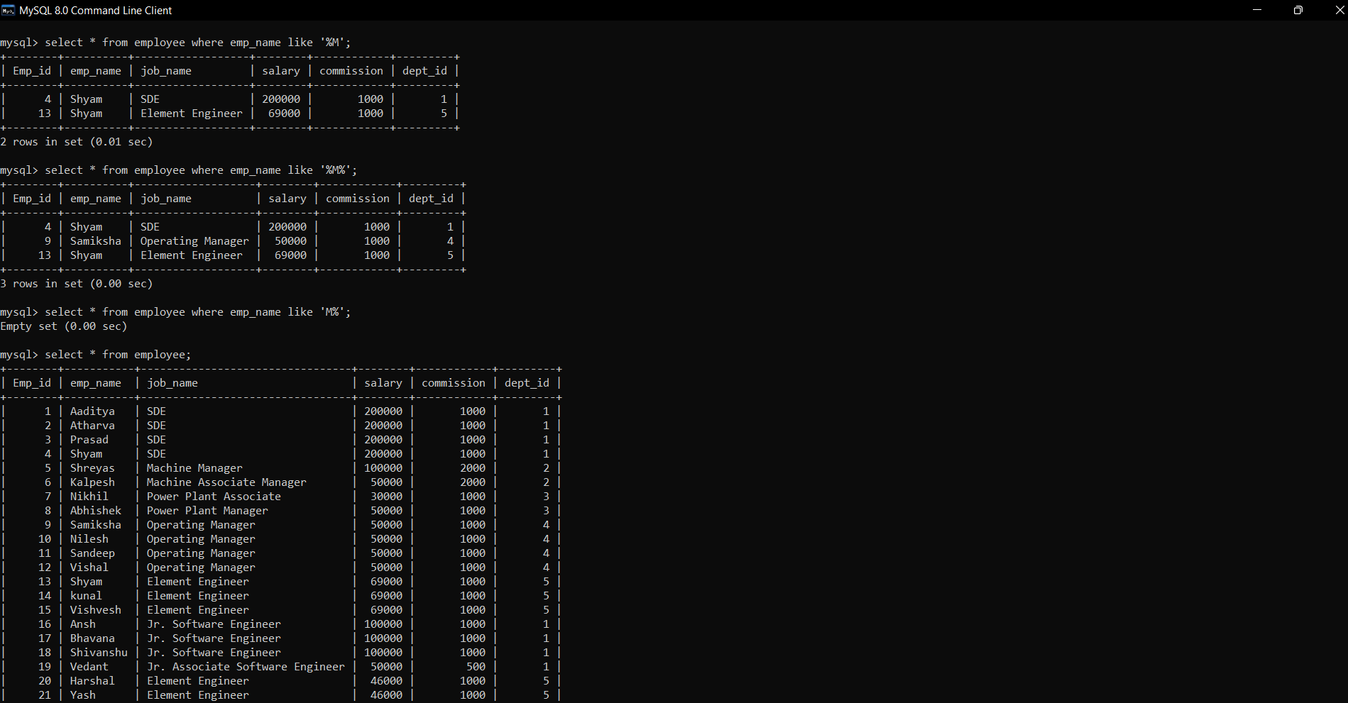

2. Display the records from emp table having employee names starts with any letter but second letter ‘M’

Answer:- Command=> select * from employee where emp_name like ‘_M%’;

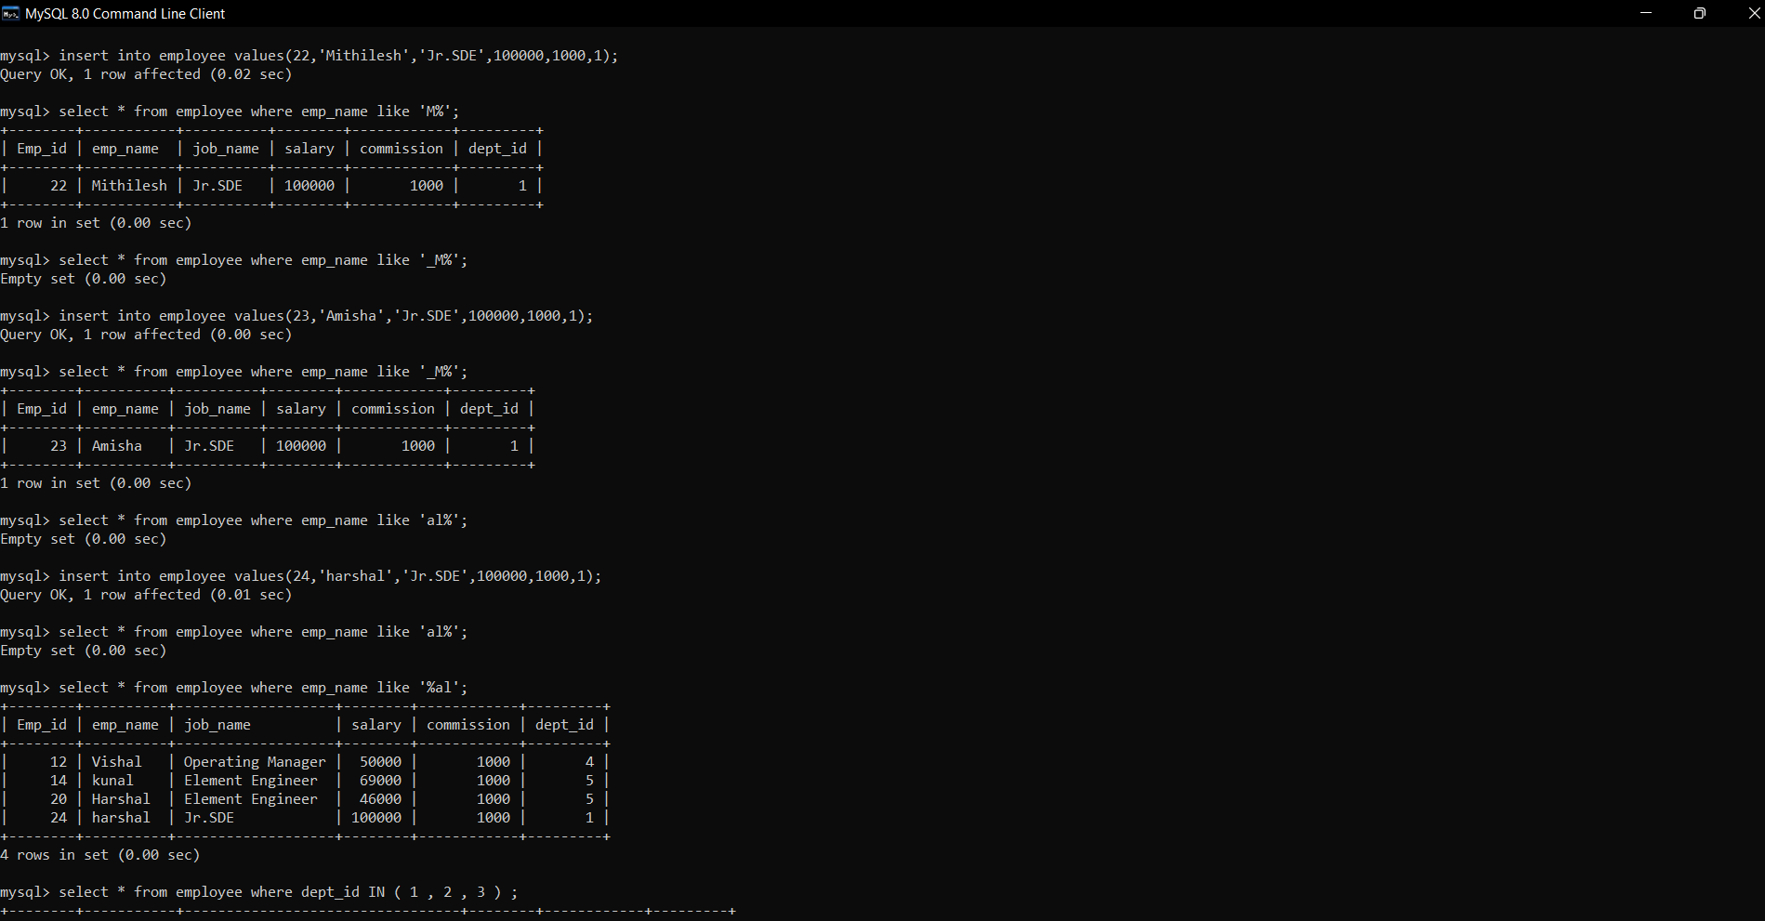

3. Display the records from emp table having employee names ends with letters ‘al’

Answer:- Commands => select * from employee where emp_name like ‘%al’;



4. Display the records from department table for 3 departments

Answer:- Command=> select * from employee where dept_id IN (1,2,3) ;

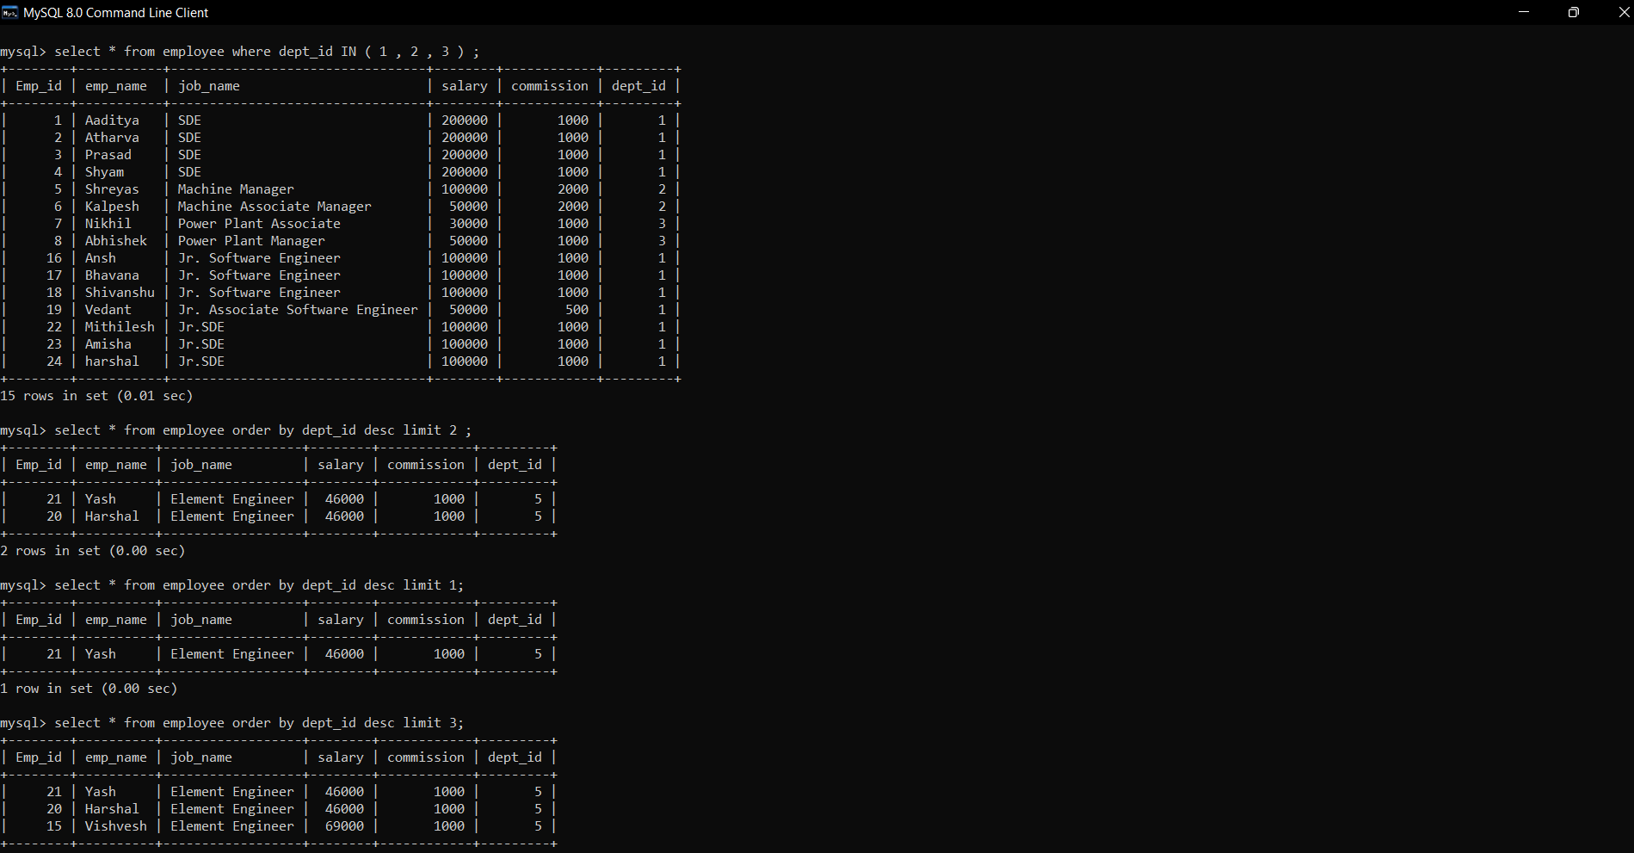

5. Display the records from department table by excluding 2 departments

Answer:- Command=> select * from employee where dept_id NOT IN (1,2) ;

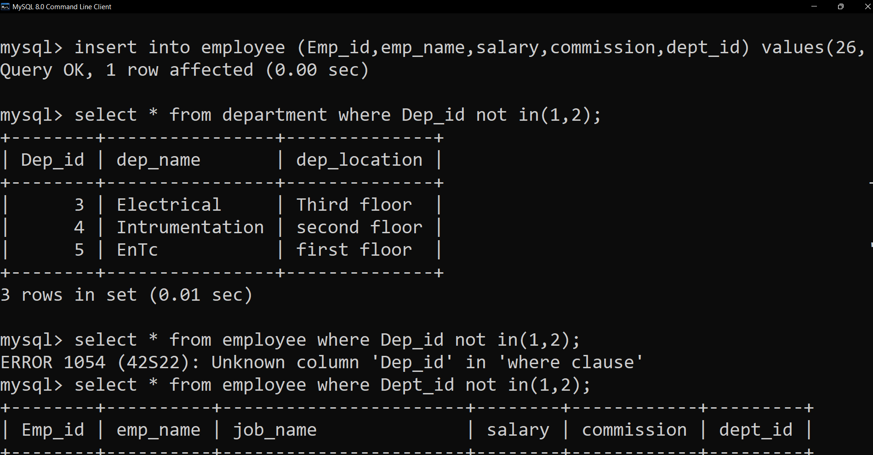

6. Insert 2 records in emp table with job column as NULL values

Answer:- Command=> insert into employee ( emp_id,emp_name,salary,commission,dept_id)

values (25,’Ajinkya’,20000,500,5), (26,’Ajit’,20000,500,5);

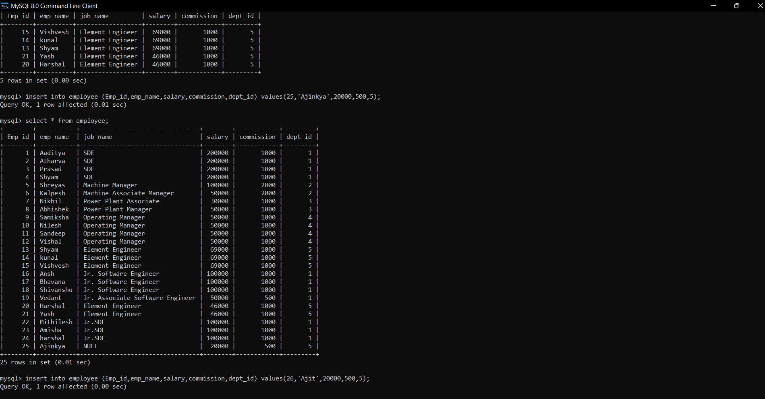

7. Display records from emp with job column is null

Answer:- Command=> select * from employee where job_name is NULL;

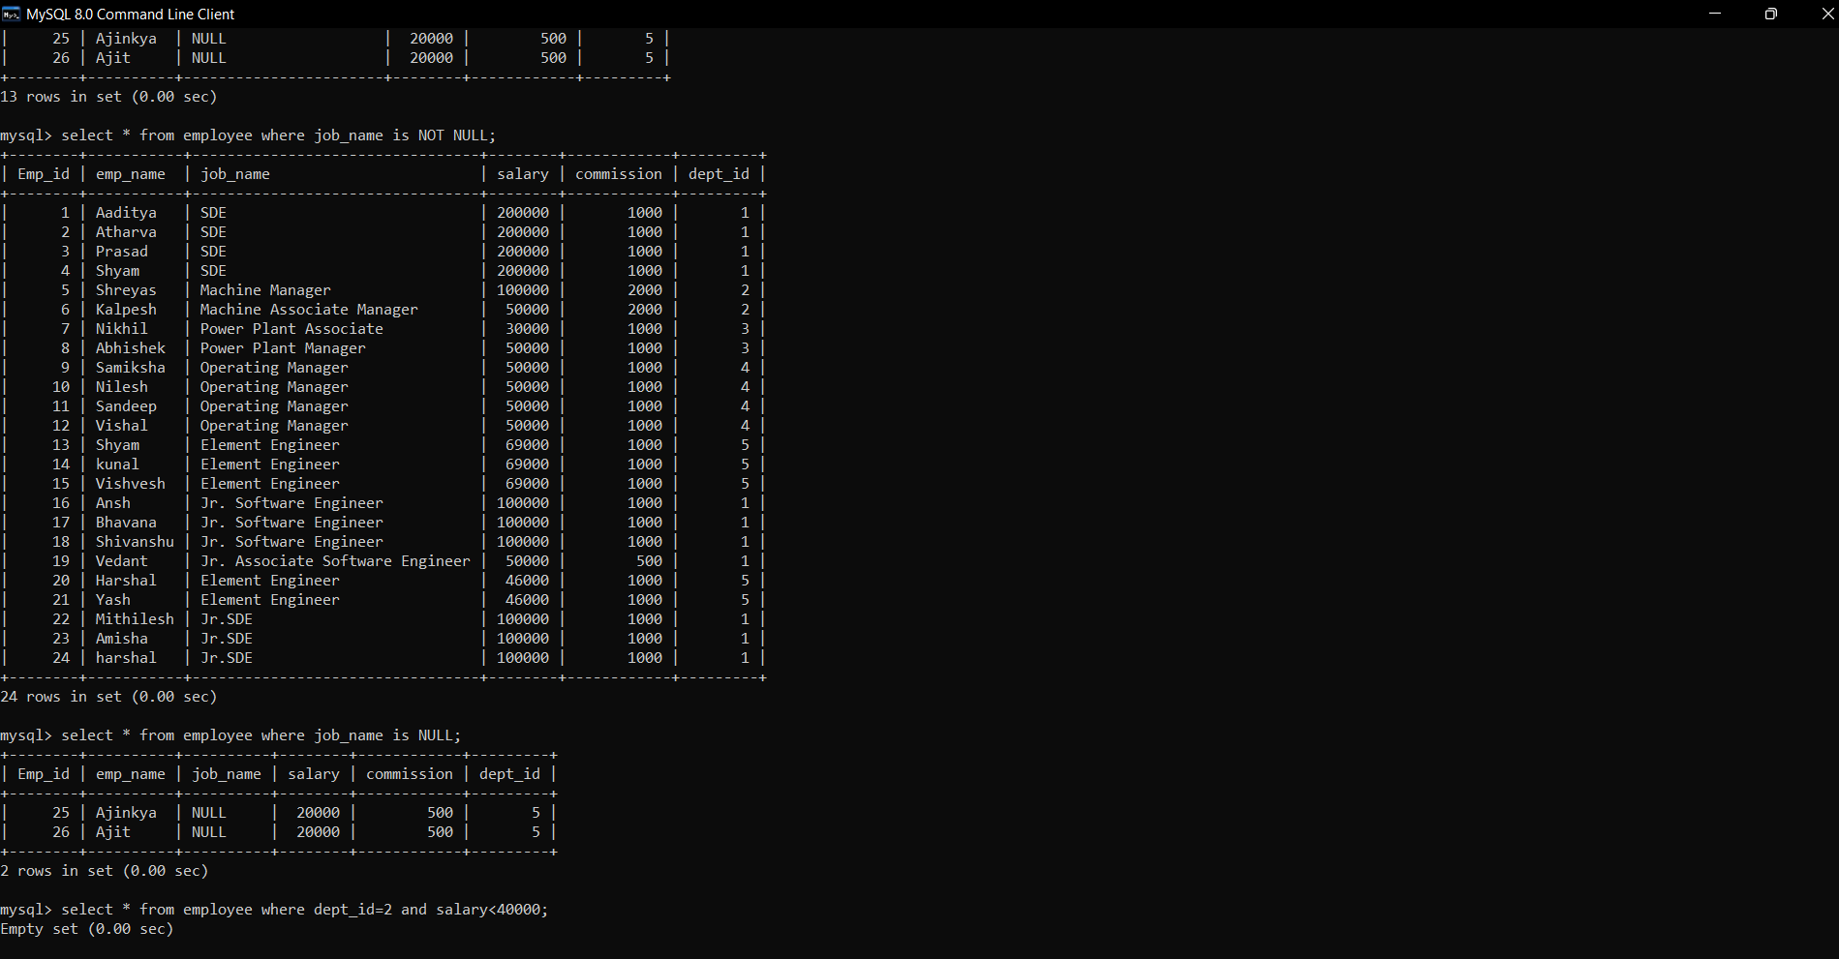

8. Display records from emp with job column is not null

Answer:- Command=> select * from employee where job_name is NOT NULL;



9. Display records from emp table with multiple conditions in Where clause such as departmentid={any value} and salary < 40000

Answer:- Command=> select * from employee where dept_id = 5 and salary < 40000;

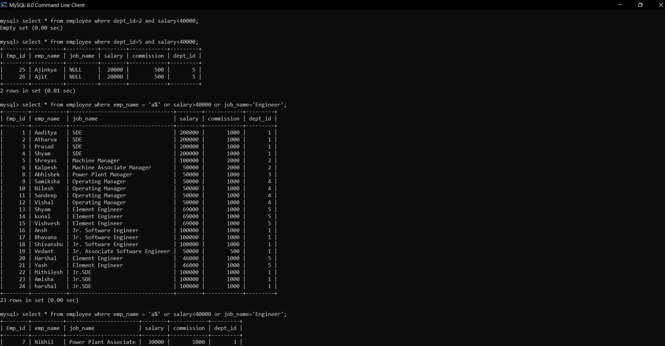

10. Display records from emp table with multiple conditions in Where clause such as emp name starts with letter ‘a’ or salary > 40000 or jobname=’officer’

Answer:- Command=> select * from employee where emp_name like ‘a%’or salary > 40000 or

Or job_name = ‘Engineer’;



11. Create a table named customer having following columns Custid int, custname varchar(100), address varchar(100)

AND

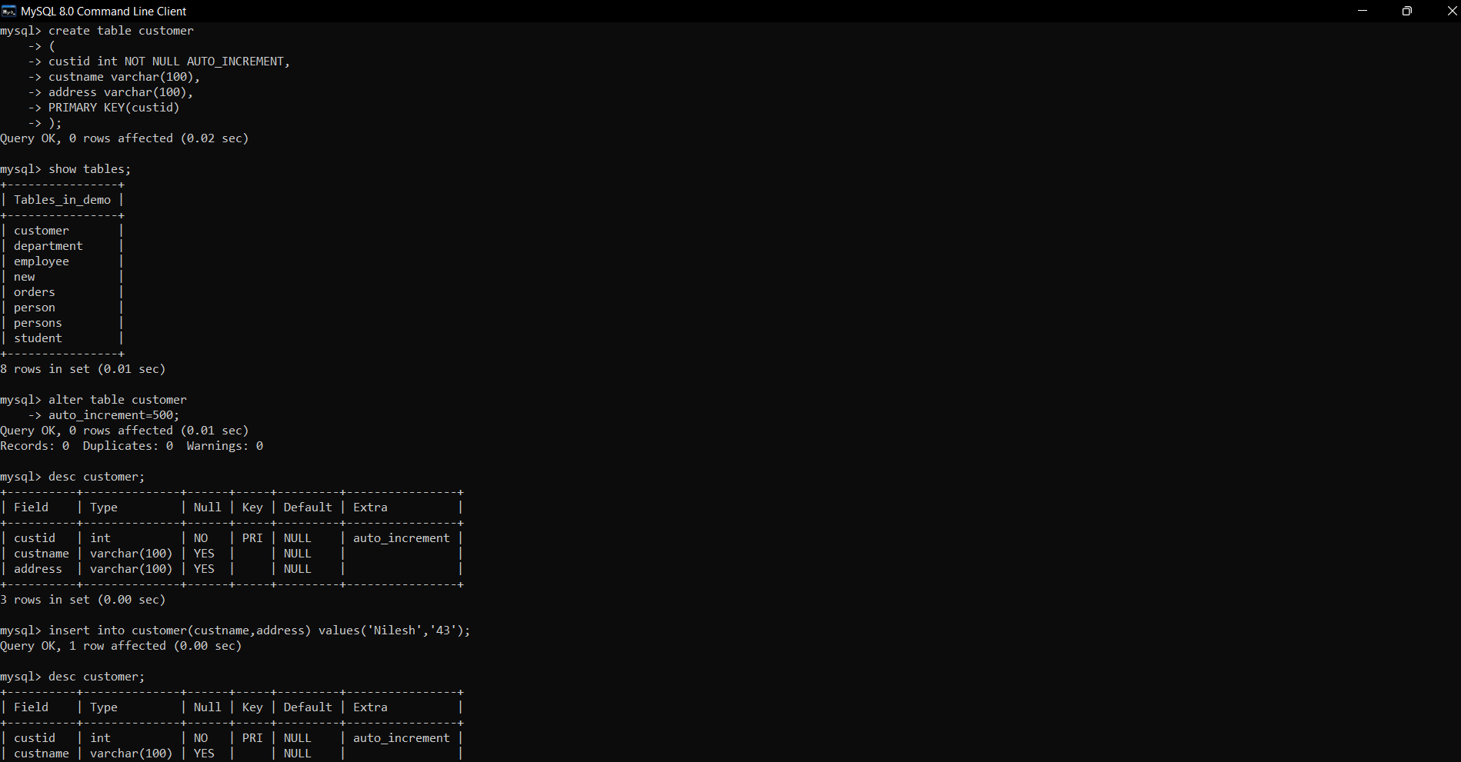

12. Set custid column as the autoincrement column and starts with 500

Answer:-

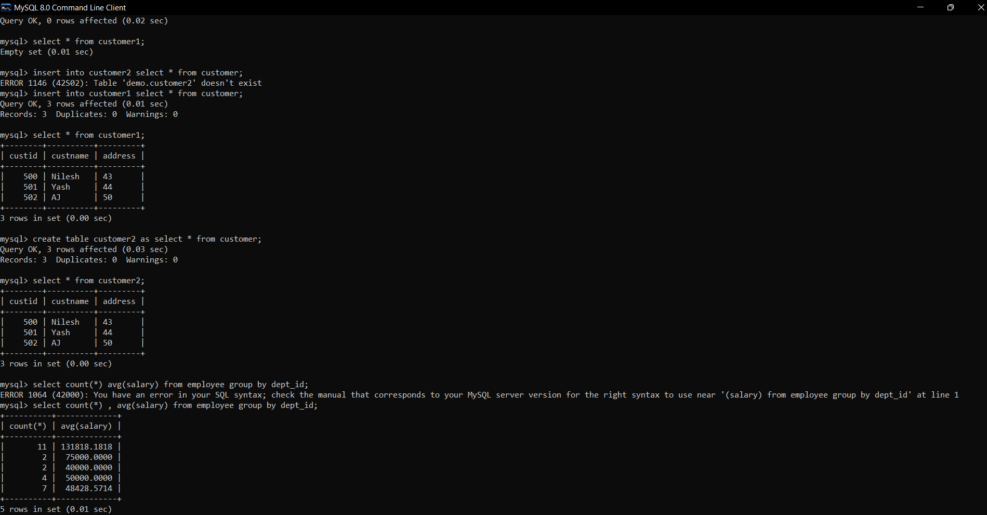

13. Insert 3 records in customer table

Answer:-

14. Create a copy of customer table named customer1 with only data from customer table

Answer:- Command=> create table customer1 like customer;

Insert into customer1 select * from customer;

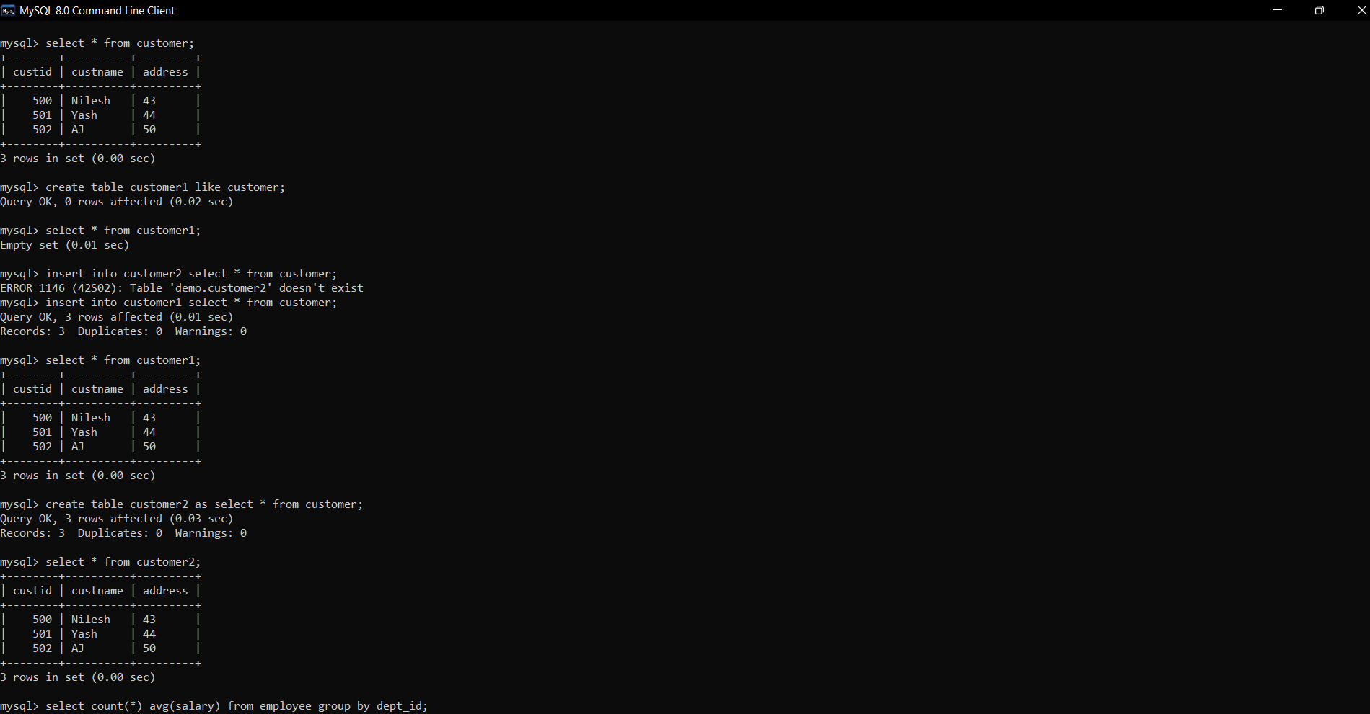

15. Create a copy of customer table named customer2 with structure and data from customer table

Answer:- Command=>create table customer2 as select * from customer;



16. Display the Minimum and Average salary of employees in each department from employee table grouped by department id

Answer:- Command=> select count(*) , avg(salary) from employee group by dept_id;

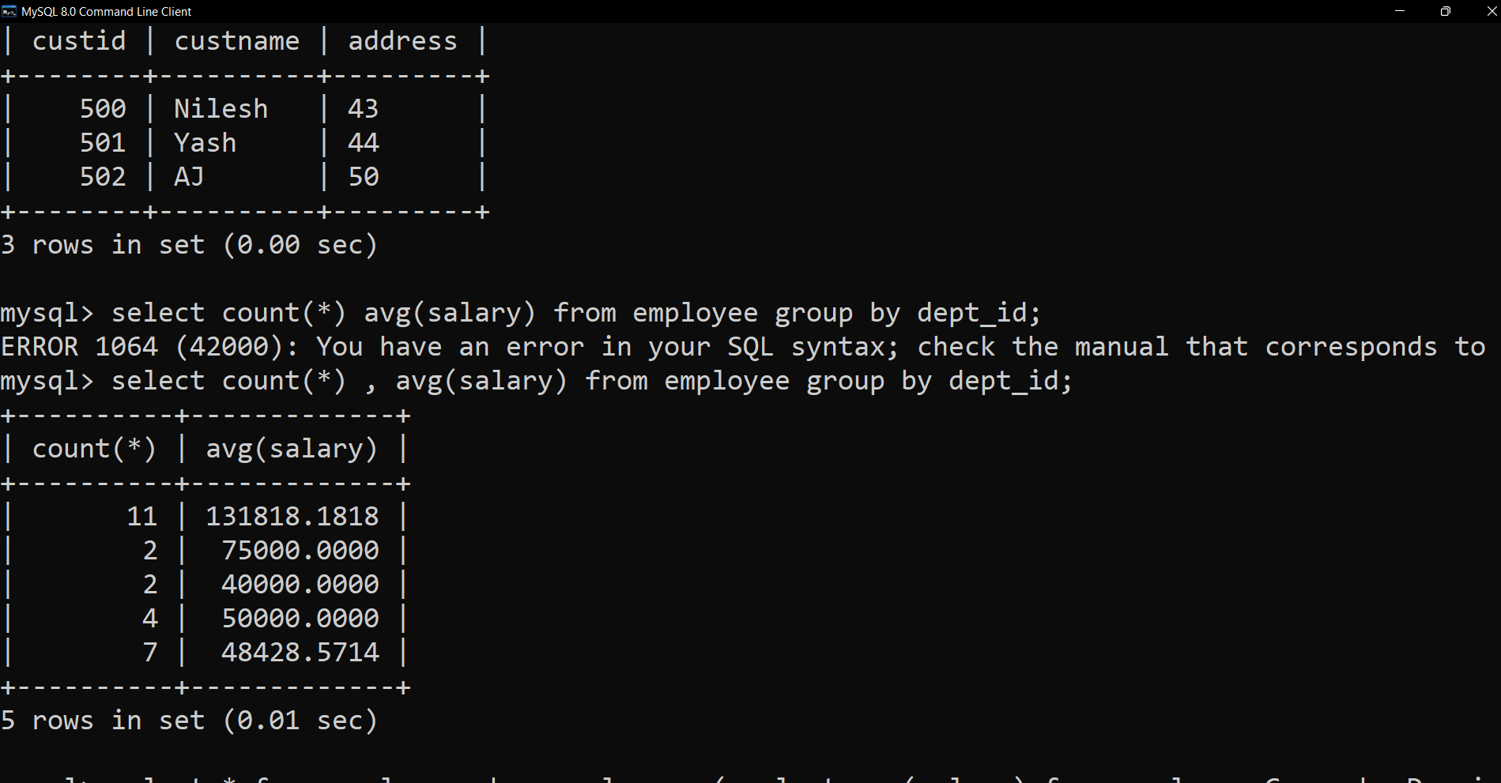

17. Display the maximum salary of employees in a department where that department has more than 5 employees

Answer:- Command=> select * from employee group by dept_id having count(emp_id) > 5;

